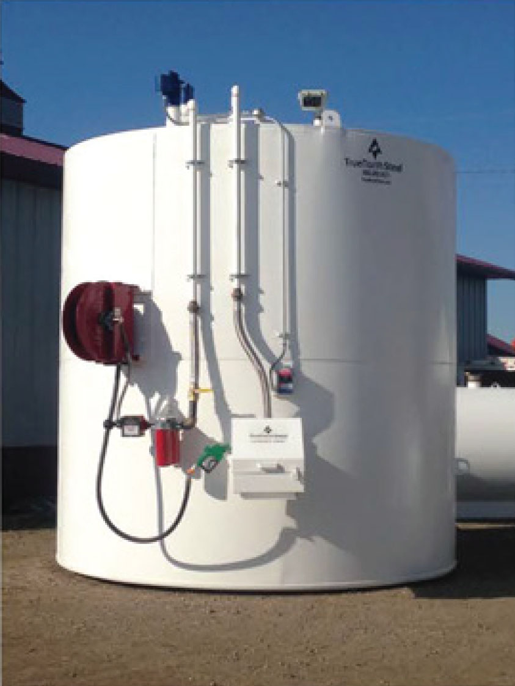

* **Steel Single Wall Tanks** for fuel, oils, fertilizer, etc.

Sizes from 300 to 50000 Gallons

* **TankScan** Web Based, fluid level displays, usage, alarms
* **OPW, Wayne, Fill-rite** Fuel Management Systems

**Marv Crawford**

**308-962-6101**

**mcrawford@orthman.com**

­

**Horizontal & Vertical**

**Double-Wall Tanks**

* Heavy duty and built to last
* Eliminate the need for an outside containment system
* Double-wall vertical FLAMESHIELD FUEL TANKS that meet STI 921 standards
* Complete turnkey packages with submergible pumps, meters, hose reels, filters/housings, and fuel level gauges

Orthman delivers the reliability your farm requires when it comes to farm fuel storage.

All of our tanks are custom built and right to spec every time – contact us today to learn more about steel tank storage solutions!

**Ag Tanks**

**Delivered**

